ABSTRACT :

This is the project of making a Job Portal Dashboard using html css and php, with the use of XAMPP server this project is made. In this project the users can post job requirements and apply for various jobs as listed by an employer, there are two pages dedicated for the user for logging in with credentials and then performing actions as required by the user that is to apply for a job there is a page for registration then login page. For the employer there is registration for the employer and the applicant on the same page to provide easiness in the registration process. After that the employer is able to access the dashboard to observe the applicants and select them accordingly, there is also a section for the employer users to add a new job category and the task for the job with Job Description. In the backend we created a database inside the server going through PHP myadmin in the XAMP by going to the localhost/phpmyAdmin and also created tables in it using MySQL editor inside it. In this way a fully functional job hiring applying dashboard was made.

OBJECTIVE:

The purpose of the project is to get familiarized with different functions of Frontend and Backend especially PHP this project was to be made using php. Creating a Job Portal dashboard was the main outcome of this project. Another objective is to get students to learn all the backend php using sever side coding and thereby learning how the data gets stored in the database

INTRODUCTION :

This is the project of making a Job Portal Dashboard using html css and php, with the use of XAMPP server this project is made. In this project the users can post job requirements and apply for various jobs as listed by an employer. Using this project there is connection being made by the potential employer and the employee so in this project there is an actual description of how exactly the jobs are being posted in the websites online and how the data is managed at the backend by the employer and there is ease of application for the employee, also there is a method to add or delete the job categories inside so that easily one can edit the JD through the dashboard.

METHODOLOGY :

1. Installation of the XAMPP server is done in the pc.
2. Then configuration of php files in htdocs folder was done inside, And a new folder Job Portal was created where all the files were made.
3. Building of basic forms using bootstrap, html was done, mainlu in this project throughout there were forms.
4. Various pages of Registration, login, career, jobs, categories, apply, uploadjob and footer was made
5. After completion of the frontend coding, backend coding was done where used the php language and then went to Xampp and created tables and connected frontend with the backend and in this wat the project was created.

CODE - Include the screenshots of RESULTS AND OUTPUT:



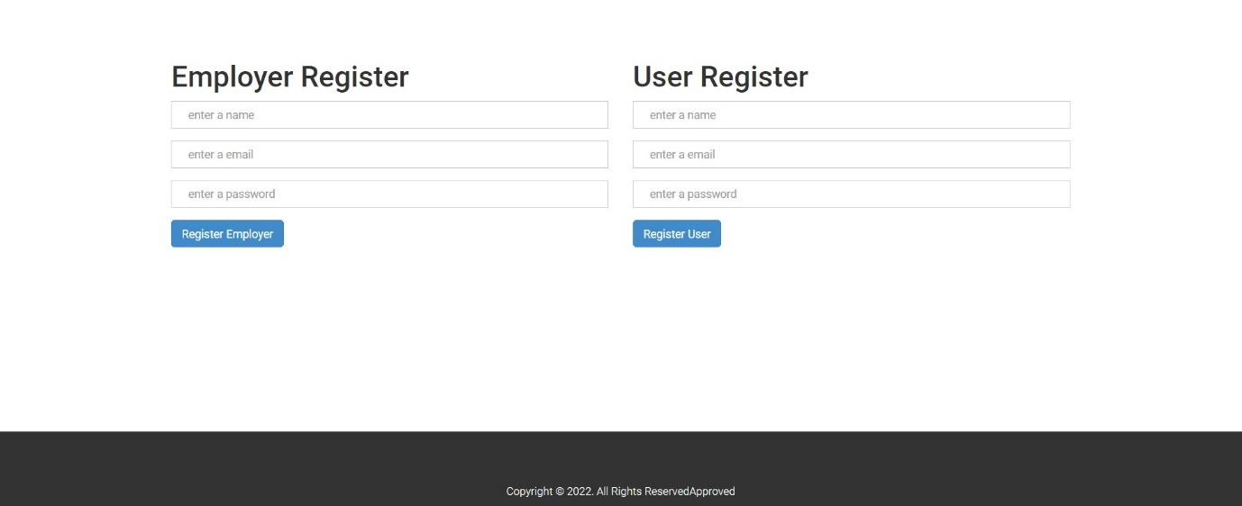

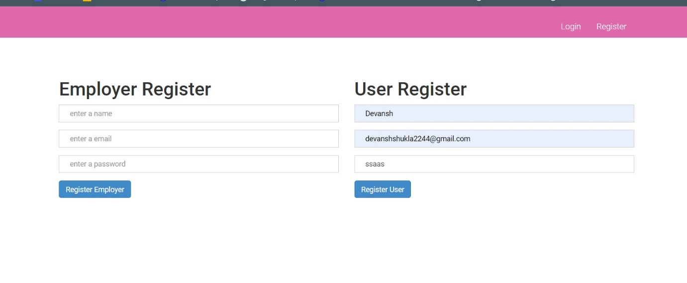

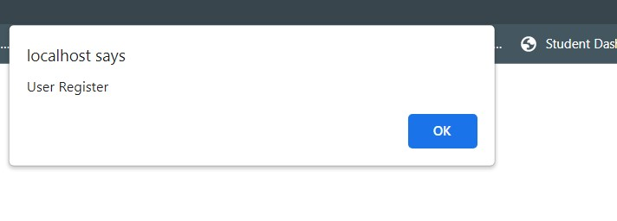



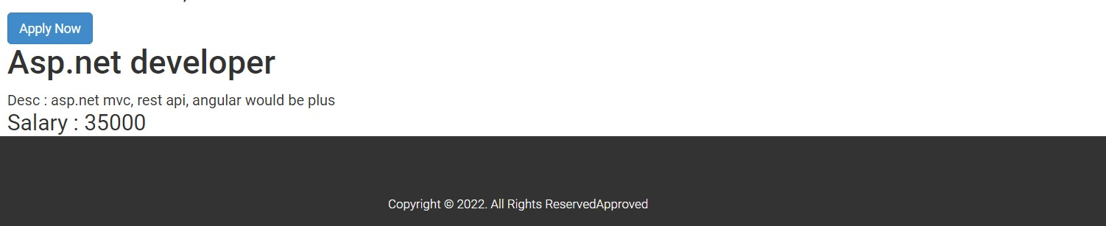

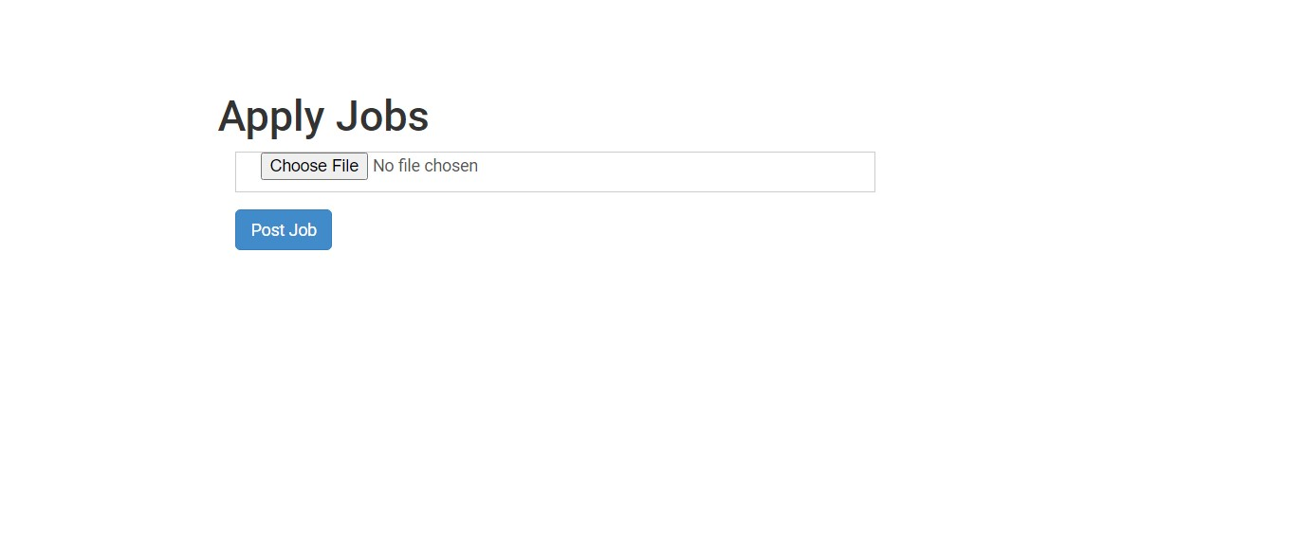

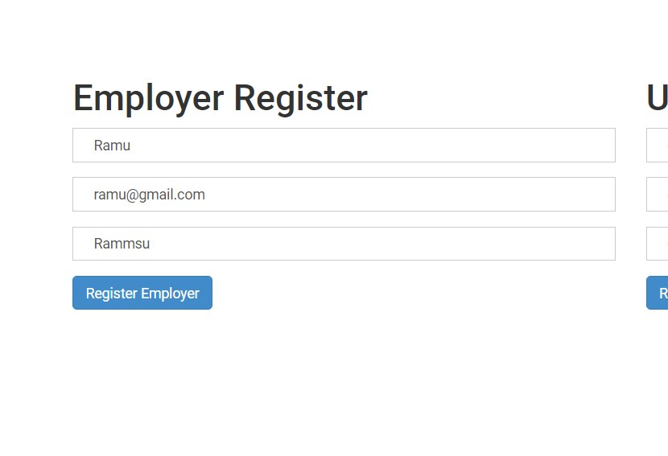

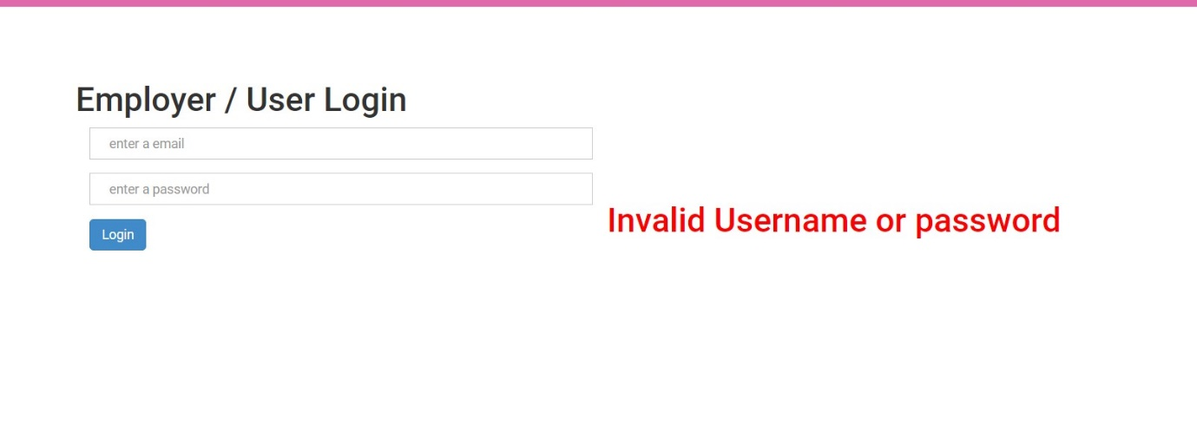

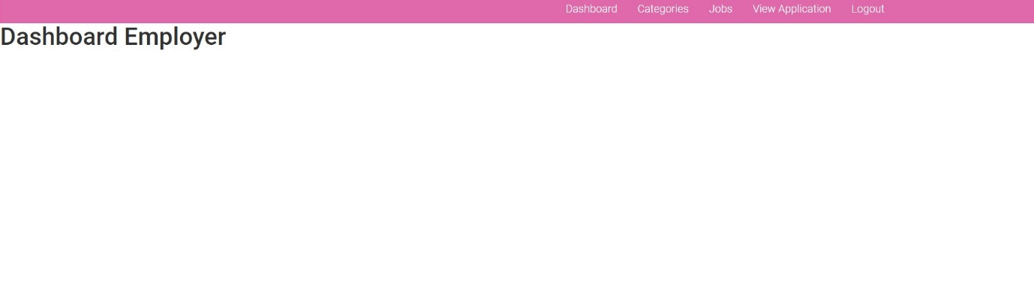

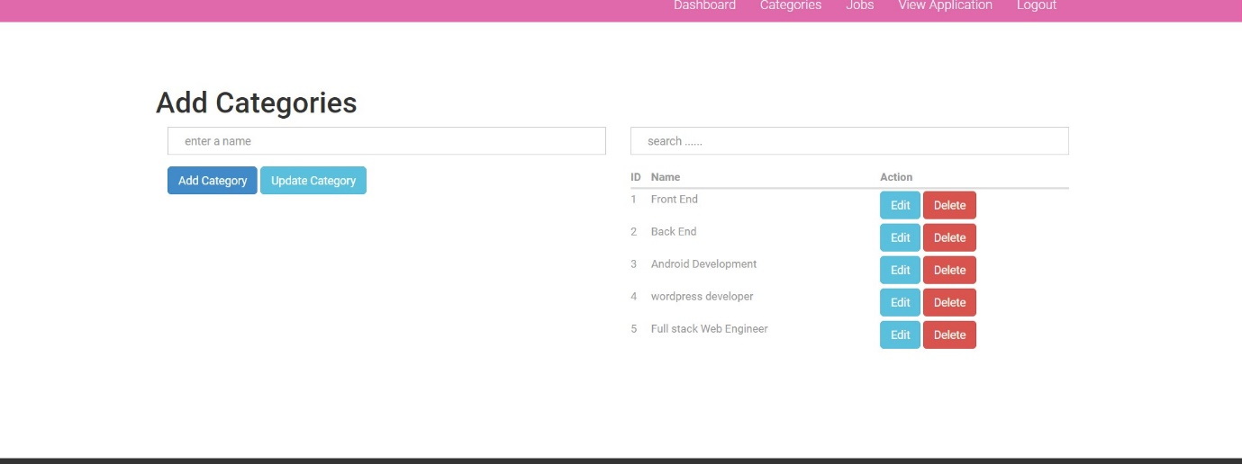

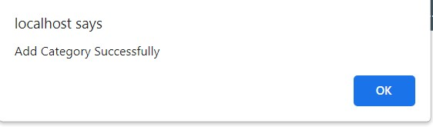

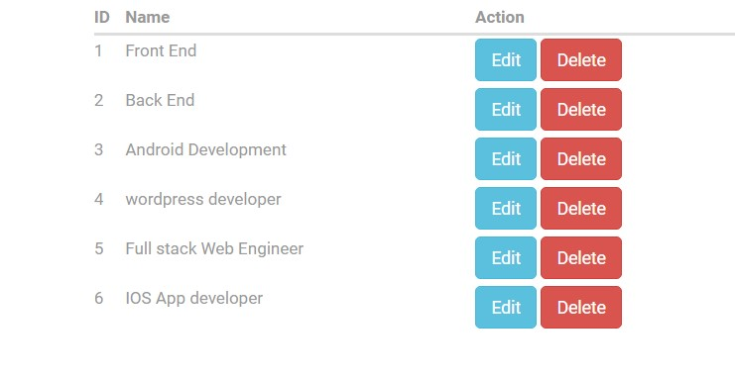



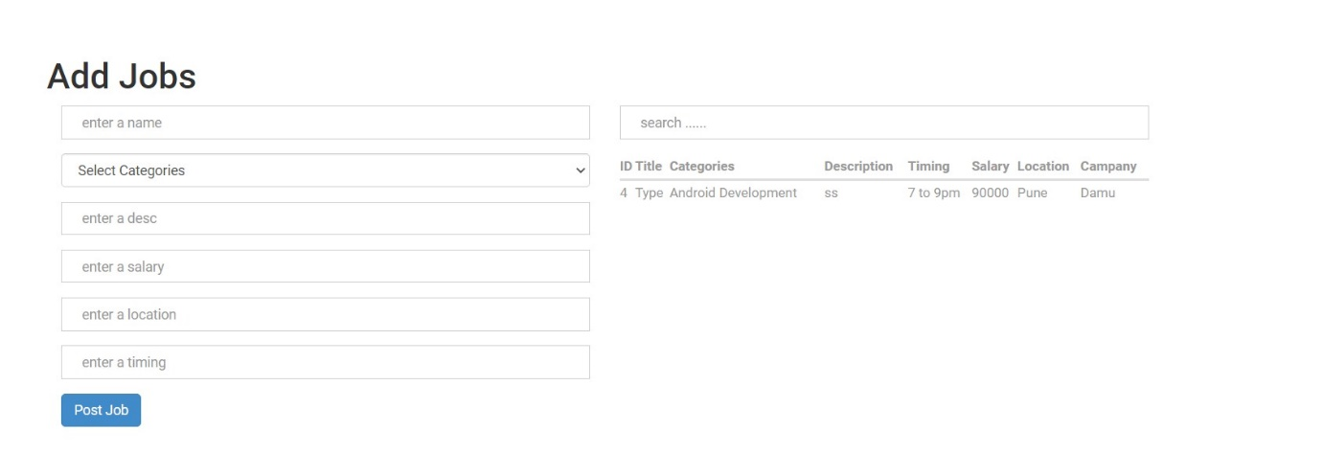

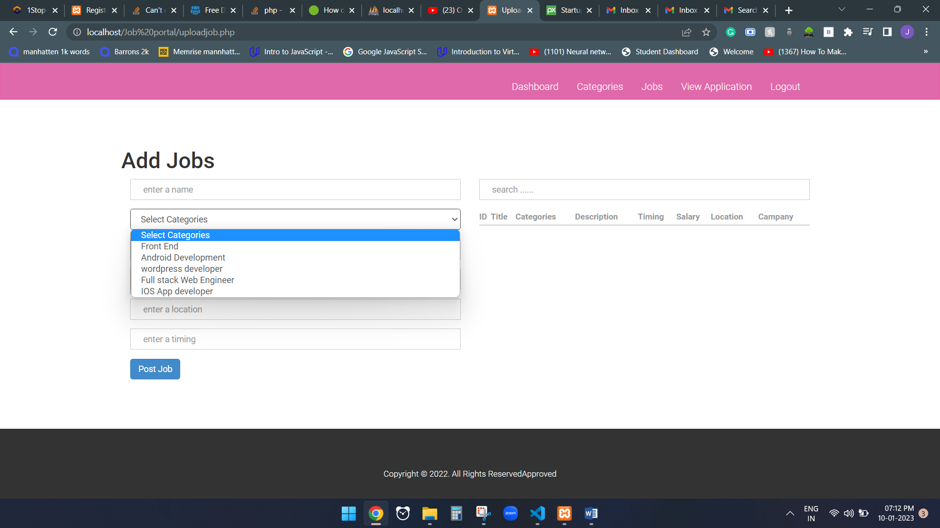

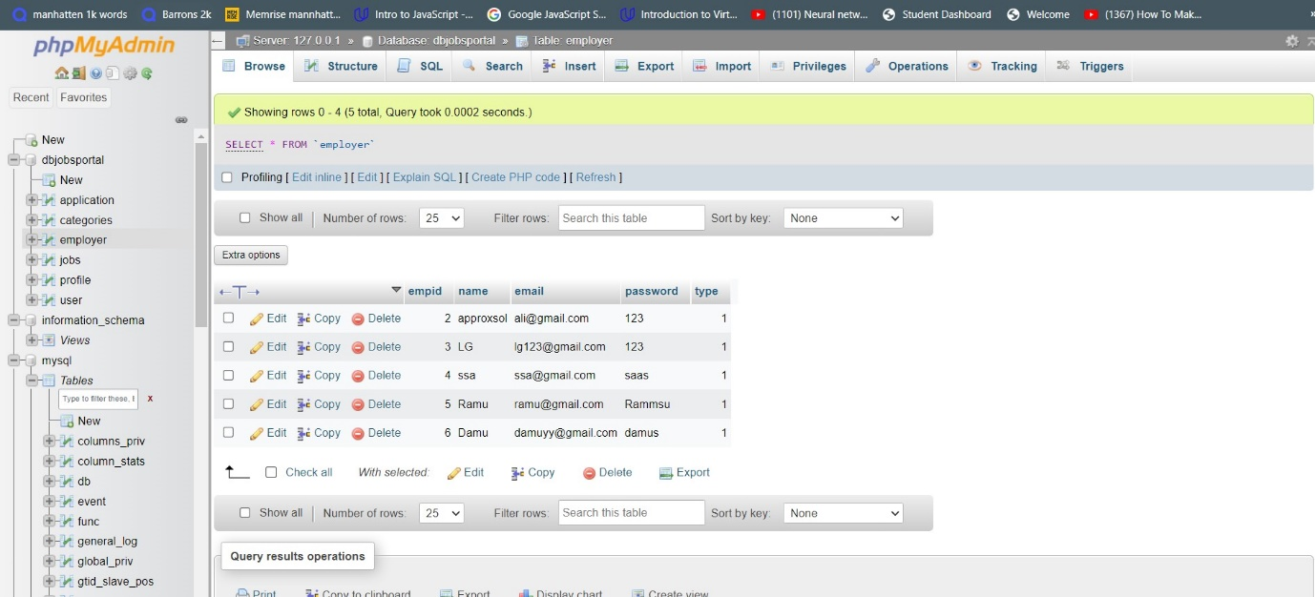

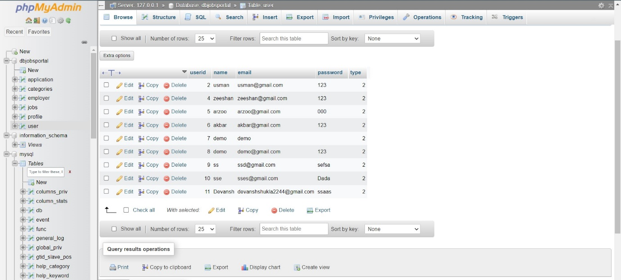

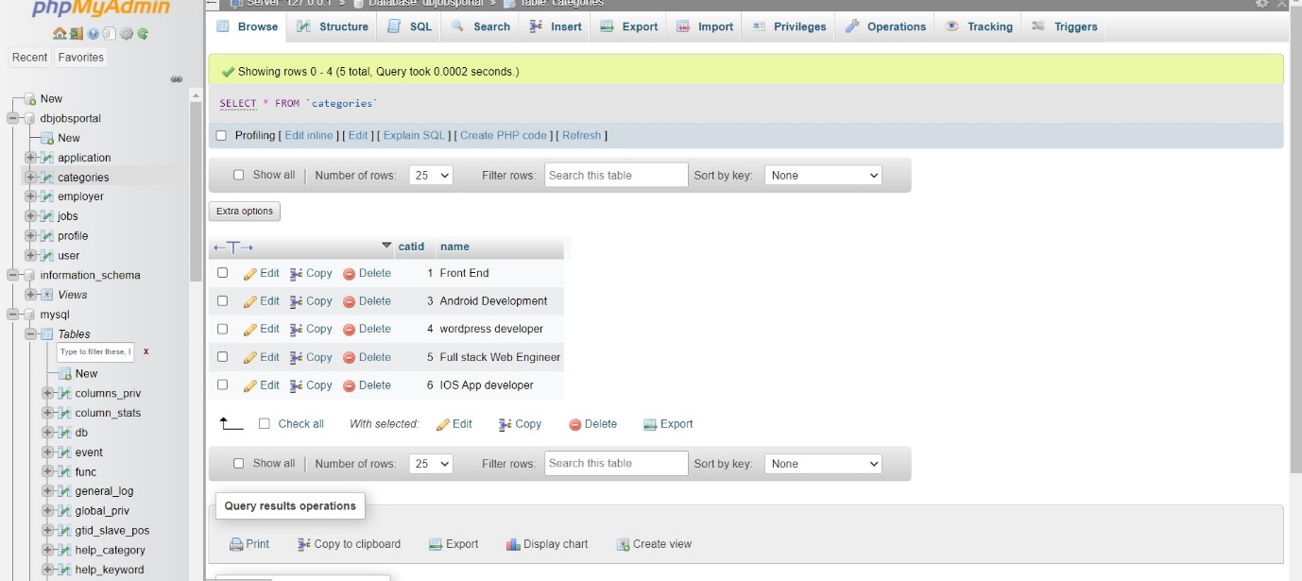

CONCLUSION:

A Job potal Dashboard was made using html, css , php. Mostly throughout the project php language is used as there was a need for backend knowledge.